# Rewiring food webs in protected areas through trophic rewilding

Globally downgraded food webs in protected areas can be partially rewired through trophic rewilding

Emilio Berti1, 2 *, Scott Jarvie1, 2, and Jens-Christian Svenning1, 2

1 Section for Ecoinformatics and Biodiversity, Department of Biology, Aarhus University, Ny Munkegade 114, DK-8000 Aarhus C, Denmark.

2 Center for Biodiversity Dynamics in a Changing World (BIOCHANGE), Department of Biology, Aarhus University, Ny Munkegade 114, DK-8000 Aarhus C, Denmark.

* Corresponding author:

* e-mail: [emilio.berti@bios.au.dk](mailto:emilio.berti@bios.au.dk)
* ORCiD: <https://orcid.org/0000-0001-9286-011X>

## Keywords

Food webs; Human-driven extinctions; Mammals; Megafauna; Rewilding; Trophic interactions.

## Introduction

Protected areas are a key instrument for biodiversity conservation, but generally harbour improverished faunas and downgraded food webs due to the human-linked prehistoric and historic megafauna extinctions. This trophic downgrading may challenge their functionality, but may be remedied through trophic rewilding, an ecological restoration strategy that uses species introductions to restore top-down trophic interactions. Yet the extent to which extant species can rewire food webs to pre-extinction levels is poorly understood. Using current and estimated natural ranges of all extant and extinct late-Quaternary mammals, we modelled climatic suitability to identify species for reintroductions or introductions as functional analogues to replace closely-related, similar-sized extinct species. We then inferred food webs in large protected areas (PAs) ≥5,000 km2 to assess the effects of Late Pleistocene extinctions on trophic complexity and quantify rewiring from rewilding. Our results show extinctions have decreased the number of trophic interactions in PAs by on average 51%. Trophic rewilding would be able to rewire on average18% of these interactions through reintroductions and introductions of functional analogues. Our findings support trophic rewilding as an opportunity to rewire food webs in PAs globally and reinstate lost trophic interactions in degraded ecosystems.

During the last 50,000 years, large-bodied animals (megafauna) have been selectively removed from ecosystems around the world in a size-selective extinction event unique for the last 66 million years (Smith et al. 2018) and strongly linked to the global expansion of modern humans (Homo sapiens). These size-biased losses have continued through the Holocene (REFS) and into the present in many areas (REF), leading to widespread trophic downgrading of ecosystems. This downsizing of faunas and simplification of food webs have a wide range of ecosystem consequences such as … Humans have degraded ecosystems worldwide, removing from the environment species, their interactions, and the ecological processes associated with them (Dirzo et al. 2014, Valiente-Banuet et al. 2015)⁠. Human-driven extirpations of mammals date back to at least the Late Pleistocene, with a large bodied size-selectivity causing extinctions of over half of megafauna genera (121 out of 196 genera ≥ 45 kg have gone extinct; (Barnosky 2008, Smith et al. 2018)⁠⁠. These extinctions removed interactions and trophic complexity from ecological networks previously maintained by pre-human biodiverse megafauna communities (Gill, 2014), reducing the regulatory effects of top-down control and the resilience of ecosystems (Estes et al. 2011)⁠. Protected areas (PAs) are a cornerstone in nature conservation,…. Nevertheless, prehistoric and historic faunal downsizing also affect PAs, potentially reducing their capacity for maintaining biodiversity as well as affected their ecological functioning in varied ways.

Trophic rewilding is a novel restoration strategy that advocates the (re)introduction of large bodied species to restore trophic top-down trophic interactions and associated tropic cascades to promote self-sustaining biodiverse ecosystems (Svenning et al. 2016)⁠⁠. For example, the reintroduction of wolves into Yellowstone National Park in 1995–1996 triggered various direct and indirect effects, as mediated by both mesopredators and cervid prey, such as to restore ecological integrity of riparian and aquatic ecosystems (Beschta and Ripple 2016)⁠. Empirical data from rewilding projects are, however, scarce and geographically biased (Tanentzap and Smith 2018)⁠, with the scientific literature on rewilding dominated by essays, perspectives and opinion papers (Bakker and Svenning 2018)⁠. Despite increasing evidence for the restoration potential of rewilding from local studies (Perino et al. 2019)⁠, there is still limited knowledge of the potential of rewilding to rewire ecological networks at a global scale.

Macroecology provides a robust framework to assess the potential of trophic rewilding to rewire ecological networks at large scales with deep-time perspectives (Mendoza & Araújo, 2019; Zhang et al., 2018). These approaches can enable comparison of functional similarities between extant and extinct species, and identify functional analogues to replace globally extinct species for rewilding projects (Pires 2017). Examination of the effects of human-driven extinctions and on biotic interactions is possible, as well as the impacts of rewilding on ecological networks (Yeakel et al., 2014; Pires et al., 2015; Marjakangas et al., 2018). Through combining paleoecological data with macroecologically-grounded reconstructions of interaction networks the consequences of extinctions and the restoration potential of rewilding can be evaluated.

In this study, we investigate the potential of rewilding to rewire terrestrial mammal food webs in both large (≥ 5,000 km2) PAs with a strict International Union for Conservation of Nature (IUCN) category and, for comparison, geographically-unbiased random areas (Fig. 1). We include the latter partly to address the non-random geographic location of PAs and to represent that there may also be opportunities for trophic rewilding outside large PAs (REF). We infer food webs which describe ecological networks of direct predator-prey interactions under three scenarios: 1) present-natural, where mammals have not been influenced by human activities through time (Faurby and Svenning 2015; Faurby et al. 2018)⁠; 2) current, where mammals are found today, except for introduced ranges; and 3) rewilding, where extant species can be reintroduced to present-natural ranges and extinct species can be replaced by closely-related, similarly-sized functional analogues that have overlapping climatically suitable habitat. We then compare the three scenarios to investigate: the effects of human-driven extinction on the number of species and predator-prey interactions (current debts); the potential recoveries through rewilding (rewilding credit); and the losses that cannot be balances out through rewilding (rewilding deficit).

## Results

Large PAs are globally strongly affected by past size-biased defaunation, with the number of species per trophic levels significantly lower at present than in the present-natural scenario, except for small herbivores and small carnivores (Table 1). The relative reductions are especially strong for megacarnivores, megaherbivores, and large herbivores, while large carnivores were also, but les strongly affected (Table 1, Fig. 2).

Trophic rewilding, as modelled here, would lead to important faunal recoveries medium recoveries for large PAs, with the strongest effects for megacarnivores and megaherbivores, intermediate effects for large herbivores, and no general effects on large carnivores, small carnivores, and small herbivores (Table 1).

Reflecting the strong past size-biased defaunation, in the large PAs, the number of interactions among trophic levels is much reduced at present relative to the no-extinction scenario (Table 2). Notably, all interactions involving megacarnivores are strongly reduced, with the link between large carnivores and large herbivores also strongly reduced, and a smaller reduction in link from large carnivores to small carnivores (Fig. 3). Megaherbivores, being largely immune to predation, are assumed to not be involved in any trophic interactions between the mammal trophic groups; hence, their strong species number reduction is not modelled to affect the trophic network.

Trophic rewilding has potential to strongly, but not completely rewire food webs to pre-extinction conditions. Under the rewilding scenario, the relative increase in interactions was strongest for megacarnivores-large herbivores and megacarnivores-small carnivores, medium for megacarnivores-large carnivores and megacarnivores-small herbivores, and small for large carnivores-small carnivores, while was not significant for other interactions (Table 2).

In the random areas, we observed similar patterns as for the large PAs, but with stronger effect sizes (see Supplement), reflecting strong scope for trophic rewilding here if societal conditions allow.

## Discussion

Our results show that Late Pleistocene extinctions severely degraded food webs worldwide by removing higher trophic levels and their predator-prey interactions, likely weakening top-down control processes. We also found current debts can be largely reversed by a rewilding scenario that minimises ecological risks and human-wildlife conflicts and that the number of species in higher trophic levels and their interactions can be restored to pre-extinction conditions. However, our results show this rewilding credit cannot completely balance current debts, as rewilding food webs had less species at high trophic levels and missed many top-down interactions of large carnivores and megacarnivores compared to the present-natural. Notably, we found current debts and rewilding credits were both higher in random than in protected areas and that rewilding deficits were mostly comparable between the two, suggesting rewilding would be particularly effective to restore species and their predator-prey interactions in regions not covered by the current network of protected areas. Overall, our findings suggest trophic rewilding has high potential to rewire food webs at global scale (Fig. 4), restoring predator-prey interactions and trophic complexity in degraded ecosystems.

Our findings that species richness declined in trophic levels of large body-sized mammals, such as megacarnivores, megaherbivores, large carnivores and large herbivores, are in line with previous evidence showing megafauna were particularly affected by Late Pleistocene extinctions (Ripple et al. 2014, Sandom et al. 2014, Smith et al. 2018)⁠. Specifically, in our simulated data the numbers of species declined on average by 41% across all trophic levels in the protected areas and by 51% in the random areas. Much of these decreases were explained, however, by losses of megafauna, particularly of megacarnivores and megaherbivores, with average declines up to 92% (Supplementary Table 3). Our results also show that the number of predatory interactions from megacarnivores and large carnivores to other trophic levels was severely reduced due to Late Pleistocene extinctions, with and average loss of interactions between all trophic levels of 51% in the protected areas and of 66% in the random areas. These declines were due mainly to losses of top-down control interactions of megacarnivores, with average declines as high as 92% (Supplementary Table 4). Overall, these decreases highlight the severe impact of human pressure in reducing top-down control and trophic complexity in natural ecosystems (Estes et al. 2011, Mendoza and Araújo 2019)⁠.

Our results show that rewilding has a high potential to rewire food webs at global scales. Rewilding has been suggested as a novel restoration approach to promote self-sustaining biodiverse ecosystems (Svenning et al. 2016)⁠. As predator-prey interactions and trophic complexity are part of biodiverse, resilient communities (Tylianakis et al. 2010)⁠, our findings highlight the opportunities to restore ecosystems to species-rich, stable states through rewilding. Importantly, as the numbers of megacarnivores and large carnivores and their predatory interactions increased in the rewilding scenario, our findings show that predation top-down control, weakened worldwide by human activities (Estes et al. 2011, Ripple et al. 2014)⁠, can be partly restored through rewilding to present-natural levels.

Our findings provide new evidence of the possible recoveries achievable through rewilding. Specifically, we found that rewilding can restore the number of species in all trophic levels by 11% of the present-natural proportion on average for protected and by 21% on average for random areas. Recoveries were particularly large for megafauna-related trophic levels, with increases in the average number of megacarnivores up to 36% and of megaherbivores up to 23% (Supplementary Table 3). These results suggest also that, despite our model did not quantify the interactions between herbivores and plants, the recoveries in the numbers of megaherbivores and large herbivores can reinstate top-down control on plants, facilitating open vegetation landscapes that host highly-bidiverse communities (Bakker et al. 2016). The number of predator-prey interactions also recovered by 18% of the present-natural proportion on average for protected areas and by 36% on average for random areas. Also in this case, the recoveries were largely concentrated in interactions involving megafauna, with the largest increase for predator-prey interaction between megacarnivores and large carnivores as high as 50% (Supplementary Table 4). Importantly, as our model quantified only direct predator-prey interactions, our results might underestimate effects emerging from indirect interactions between species, e.g. by removing herbivore pressure on vegetation (Atkins et al. 2019)⁠, that often lead to trophic cascades shaping ecosystems (Estes et al. 2011)⁠.

Despite we found rewilding has high potential to restore food webs to pre-extinctions states, our results show that complete recoveries cannot be achieved under the conservative rewilding scenario examined here. In particular, replacements of extinct species were restricted to extant species that were phylogenetically closely-related and had similar body sizes. This was to minimise ecological risk of introduction (REF) and to ensure replacement species were functionally similar to extinct species (Donlan et al. 2006)⁠ and that could act as functional analogues in the food web, where phylogeny and body mass explains to a large extent the structure of predator-prey networks (Eklöf et al. 2012, Gravel et al. 2013)⁠⁠. However, many extinct species did not have any available functional replacement, as closely-related species went all extinct (e.g. Thylacinidae), and could not be replaced. Hence, complete restoration of food webs was not possible under these constraints of the conservative rewilding scenario examined here.

Our findings of comparable patterns for losses and recoveries in protected and random areas suggest our analyses were not influenced by the geographic biases of the current network of protected areas. As current network of protected areas poorly covers biodiversity hotspots for mammals (Daru et al. 2019)⁠, our analyses might have been affected by the non-random locations of protected areas. Our results show, however, qualitatively similar current debts and rewilding credits in protected and random areas, although with higher losses and recoveries in random areas. Large protected area with IUCN management status I-II are localised in regions with low human pressure (Joppa and Pfaff 2009)⁠. Hence, losses were less severe in magnitude for protected areas as well as potential recoveries through rewilding. Importantly, however, rewilding deficits were comparable in magnitude between protected and random areas: under the rewilding scenario, the number of species in all trophic level was on average 70% of the present-natural for both protected and random areas, while the number of predator-prey interactions was on average 67% and 69% of the present-natural for protected and random areas, respectively. These findings suggest food webs can be rewired to similar proportion of their pre-extinction levels in both area types worldwide. Overall, these results indicate our findings are representative of current debt, rewilding credit, and rewilding deficit at the global scale and that larger losses, but also potential recoveries, can be expected outside large, strictly-managed protected areas.

Here, we used a theoretical approach to investigate how Late Pleistocene extinctions altered food webs and how rewilding can restore them. Yet, the necessary starting point for rewilding is human-wildlife coexistence (Perino et al. 2019)⁠. Success of rewilding depends on complex socio-ecological factors, particularly on the support from local people (Ceauşu et al. 2019)⁠. Rewilding can cause conflicts with local stakeholder, e.g. due to livestock predation or damages to crops and pastures (Pereira and Navarro 2015, p. 72–74)⁠. Moreover, people not directly damaged by wildlife can also negatively perceive rewilding projects depending on how they are implemented (Theunissen, 2019). Such conflicts can be resolved by identifying benefits and costs of wildlife in a socio-ecological framework (Ceauşu et al. 2019)⁠, by adopting compensation schemes for damages caused by wildlife (Ravenelle and Nyhus 2017)⁠, and by implementing rewilding with realistic goals (Pedersen et al. 2020)⁠.

Despite disagreement and oppositions to rewilding (e.g. Nogués-Bravo et al. 2016, Rubenstein and Rubenstein 2016⁠), species are, in some cases, re-expanding to their natural ranges and passive rewilding has already started. In Europe, for instance, land abandoned has increased in recent decades (Verburg and Overmars 2009)⁠, promoting wildlife’s comeback (Chapron et al. 2014, Ceausu et al. 2015)⁠. Importantly, traditional conservation and restoration approaches, economically expensive and resource-demanding, have limited applicability to these large spatial scales and they are unlikely able to protect biodiversity efficiently (Pereira and Navarro 2015)⁠. Our results show that rewilding can reinstate trophic complexity and top-down effects at large scales, hence suggesting rewilding has the potential to be an effective restoration strategy alternative or complementary to more traditional approaches (Pereira and Navarro 2015)⁠. Overall, our findings that rewilding can restore trophic complexity at large spatial scales support rewilding as an unprecedented opportunity to restore landscapes altered by human activities to self-sustaining, biodiverse ecosystems (Svenning et al. 2016, Perino et al. 2019)⁠.

In conclusion, our study shows that human-driven extinctions severely degraded food webs worldwide and that rewilding has the potential to rewire food webs and restore trophic interactions at global scale. Our findings support trophic rewilding as a promising, novel restoration strategy to re-establish in defaunated ecosystems important ecological functions, such as top-down control and trophic complexity (Estes et al. 2011, Beschta and Ripple 2016)⁠. Despite humans have nearly caused a new mass extinction, simplifying trophic complexity of ecosystems worldwide (Mendoza and Araújo 2019), defaunation can be partly reverted through rewilding (Svenning et al. 2016)⁠. Here, we showed how a plausible rewilding scenario can rewire food webs and reinstate trophic complexity at global scale, which will reinstate lost trophic interactions and promote self-sustaining biodiverse ecosystems.

## Methods

#### Overview

Our methodology follows four distinct steps: 1) we ran correlative species distribution models (SDMs) for extant terrestrial mammals to estimate their climatically suitable habitats; 2) we modelled reintroductions of extant terrestrial mammals and identified extant mammals that can be used to replace closely-related, similarly-sized extinct species in climatically suitable habitats; 3) we reconstructed food webs within protected and random areas for the present-natural, current, and rewilding scenarios; and 4) we contrasted the food webs of the three scenarios and investigated whether rewilding can rewire current food webs to present-natural conditions. These four steps are summarised below; more details are provided in the supplementary material.

Expanding upon the terminology of Genes et al. (2017)⁠, we quantified: a) current debt, the number of species and interactions lost due to Late Pleistocene extinctions; b) rewilding credit, the number of species and interactions restored under the rewilding scenario; and c) rewilding deficit, the extent of past losses not restored by rewilding. After quantifying current debt, rewilding credit and rewilding deficit, we assessed whether rewilding credit can balance current debt or if a rewilding deficit remained as food webs were not restored to present-natural conditions.

#### Species distribution models

Correlative SDMs are currently the main tools used to derive spatially explicit predictions of environmental suitability for species (Elith and Leathwick 2009)⁠. They typically achieve this through identification of statistical relationships between species observations and environmental descriptors, and are then projected onto landscapes that fall within the species ‘environmental envelope’ (Guisan and Thuiller 2005)⁠. Following previous studies (Jarvie and Svenning 2018, Monsarrat et al. 2019)⁠, we used current and present-natural range maps from the PHYLACINE database (Faurby et al. 2018)⁠ to overcome biases when running SDMs due to anthropogenic range contraction of species (Faurby and Araújo 2018)⁠. PHYLACINE current ranges were generated from the IUCN range maps for current, natural, and reintroduced ranges only (IUCN 2019) By using both current and present-natural ranges we thus limited biases in species occurrence records due to anthropogenic modification of species distribution ranges (Faurby and Araújo 2018)⁠. Present-natural ranges are estimates of where species could be today in the complete absence of influence of modern humans (*Homo sapiens*) through time and were derived using known historic distributions of species, fossil co-occurrence data, and known range modifications caused by humans (Faurby and Svenning 2015)⁠. We generated presence locations for extant terrestrial mammals within combined current and present-natural range maps with a 20 km separation distance, excluding locations reported above the highest elevation for each species in the IUCN Red List or, if not stated, 4,000 meters, which is roughly the 95 percentile for upper elevations of mammals (IUCN 2019). Elevation was determined for presence locations using the EarthEnv-DEM90 digital elevation model (Robinson et al. 2014)⁠. We did not model species with less than 10 presence locations, thus excluding 76 species with restricted ranges. In total, we modelled 4,130 of the 4,206 living terrestrial mammals.

As environmental predictors for the SDMs, we used four bioclimatic variables from the WorldClim v.2 database: maximum temperature of the warmest month, minimum temperature of the coldest month, precipitation of wettest quarter, and precipitation of driest quarter. We selected these variables as they capture extreme conditions and, thus, likely represent factors limiting the species’ distributions (Guisan et al. 2017). The four variables were downloaded at 2.5 arc-minute resolution (Fick and Hijmans 2017)⁠ and reprojected to a 5 km resolution using bilinear interpolation with a Behrmann equal-area projection. To minimize potential issues with multi-collinearity, we ensured that the variance inflation factor among the climatic variables was below 4 (O’Brien 2007)⁠.

To model the climatic suitability of terrestrial mammals, we fitted maximum entropy (Maxent) models as implemented in the maxnet R package (Phillips et al. 2017)⁠. Maxent is a presence-background approach, in which environments occupied by a species are contrasted with the available environmental space (Elith et al. 2011, Merow et al. 2013)⁠. Maxent models were fitted with the default settings, besides disabling threshold features to avoid locally overfitted response curves (Merow et al. 2013)⁠ and increasing the number of randomly sampled background records from 10,000 up to a maximum of 100,000 to ensure greater representation of environmental space (Guevara et al. 2018)⁠. For the background area, we calculated species-specific buffers from combined current and present natural ranges to reflect the dispersal abilities of each species (Barve et al. 2011)⁠. Following previous studies (Poo-Muñoz et al. 2014, Hof et al. 2018)⁠, we calculated the buffer size as the maximum distance from the centroid to the edge of the largest continuous range (see Supplementary Fig. 1 for an example).

We assessed the predictive performance of Maxent SDMs through five-fold cross validation using the average Continuous Boyce Index (CBI; Hirzel et al. 2006), which indicates how much models discriminate against random expectation, and the average Area Under the Curve (AUC) of the Receiver Operating Clot (ROC; Swets 1988⁠⁠), which indicates how well models differentiate between presences and pseudo-absences regardless of the degree of difference between them. Values of CBI range between -1 and 1, where values > 0 indicate the model's output is positively correlated with the true probability of presence and values < 0 indicate it is negatively correlated with the true probability of presence. AUC values range from 0 to 1, where values ≤ 0.5 are models with discrimination no better than random to 1 for models with perfect discrimination (Fielding and Bell 1997)⁠. Model fit was inspected by five-fold cross validation of the average omission rate based on the minimum training presence value (ORMTP; Radosavljevic and Anderson 2014). The values of ORMTP range from 0 for models that are not overfit to 1 for models that are overfit. To convert continuous suitability predictions to binary layers indicating suitable/unsuitable habitat, we used as threshold the suitability value that maximised sensitivity and specificity (Maximum Sensitivity and Specificity; MSS), which is a more reliable than other threshold metrics when only presence data are available (Liu et al. 2016)⁠. We also assessed the performance of SDMs by comparing our projected binary suitability maps with the introduced ranges of 136 species obtained from Lundgren et al. (2018; n = 22 species) and the IUCN (IUCN 2019; n = 114 species). The introduced ranges were not used to generate presence records to train the SDMs. For three species found in both datasets (*Cervus elaphus*, *Ovibos moschatus*, and *Rangifer tarandus*), we assessed performance of SDMs using only the ranges from Lundgren et al. (2018)⁠.

Predictive performance of the SDMs was on average very high to excellent (mean CBI = 0.87; mean AUC = 0.85), while model overfitting was generally low (mean ORMTP = 0.07). The SDMs predicted on average 62% of introduced ranges (Supplementary Fig. 2). See Supplementary Table 1 and Supplementary Fig. 2 for further details on predictive performance of SDMs. These results indicate that SDMs give reliable projections of climatically suitable habitat for terrestrial mammals.

## Selection of rewilding candidates

To select rewilding candidates, two steps were followed: 1) we modelled reintroductions of extant terrestrial mammals into their present-natural ranges; 2) we identified extant mammals that can be used as functional analogues to replace closely-related, similarly-sized extinct species in climatically suitable habitats. Reintroductions of extant mammals were always prioritised over introductions of functional analogues, as moving species outside their indigenous range is inherently riskier than reintroduction due to unforeseeable uncertainties and ecological risks (Fernández et al. 2017). We further constrained functional analogues to come from the same family and to be within 50% of the body mass range of the extinct species, with two exceptions: 1) extinct megaherbivore ≥ 1,000 kg (Malhi et al., 2016) from the Proboscidea order were allowed to be replaced by the two extant elephants (*Elephas maximus* and *Loxodonta africana*). The rationale being that extant elephants are often considered as functional analogues of extinct megaherbivore proboscidean in many areas of the globe (Donlan 2005, Donlan et al. 2006, Svenning 2007)⁠, due to their general phenotypic similarity (large body size, tusks, trunk) and because they promote similar key ecosystem processes, e.g., nutrient cycles and vegetation clearing(Janzen and Martin 1982, Donlan et al. 2006)⁠. 2) Extinct Felidae and Ursidae megacarnivores ≥ 100 kg (Malhi et al. 2016) were allowed to be replaced by extant megacarnivores within the same family because they play an integral part of a complete animal community, influencing ecosystems by regulating the abundance and activity of large herbivores that are smaller than megaherbivores, either through direct predation or by behavioural changes induced by generation and shaping of “landscapes of fear” (Laundré et al. 2010)⁠. For functional analogues, we examined each biogeographic realm separately due to these being areas where ecological and evolutionary processes operate strongly (Olson et al. 2001, Olson and Dinerstein 2002)⁠. We excluded Antarctica because no terrestrial mammal lives there and Oceania because no terrestrial protected areas ≥ 5,000 km2 with strictly managed IUCN categorisation are found there (Figure 1).

To avoid negative impacts from introductions of functional analogues into present-natural ranges of similarly-sized – i.e., within 50% of the body mass – extant species of the same taxonomic group, we excluded the functional analogue to prevent potential issue due to competition between two species (Linnell and Strand 2000)⁠. For the remaining functional analogues, we selected the species that had the largest climatically suitable range overlapping within the present-natural range of the extinct species in each biogeographic realm. We did not select species for rewilding that violated any of the above conditions. See Supplementary Fig. 3 for a schematic representation for the selection of functional analogue. In total, we found 94 living species that can act as functional analogues to replace 127 of the 334 terrestrial mammals extinct during the Late Pleistocene (Supplementary Table #).

## Reconstructed food webs in both large protected areas and random areas

To investigate the potential of rewilding to rewire terrestrial mammal food webs, we reconstructed food webs in large protected areas and geographically-unbiased random areas at a global scale. We selected protected areas with a strict IUCN management categories (Ia: strict nature reserves; Ib: wilderness areas; and II: national parks) as they represent sites where trophic rewilding is likely more feasible today, being geographically isolated and with generally less human pressurestrictly-controlled human access (Dudley et al. 2013). We selected large protected areas to be ≥ 5,000 km2 as this size should be sufficient for viable, biodiverse megafauna populations to exist (Woodroffe and Ginsberg 1998, Cantú-Salazar and Gaston 2010, Ripple et al. 2015)⁠. The ≥ 5,000 km2 area is also a pragmatic trade-off between a possibly optimistic cut-off of, e.g., 100 km2 (Ripple et al. 2015⁠) and an overly-conservative cut-off, e.g., 25,000 km2 (Cantú-Salazar and Gaston 2010)⁠. For the protected areas, we used spatial geometries from the World Database of Protected Area (WDPA; UNEP-WCMC & IUCN 2019, downloaded June 2019). Following previous global studies (Runge et al. 2015)⁠, we excluded protected areas without detailed geographic information, with unknown management status, UNESCO Biosphere Reserves, marine-only sites as well as the marine portion of coastal sites, and not considered protected areas internationally. We then dissolved adjacent geometries, assigning overlapping areas the strictest IUCN category of all protected areas in that location following WDPA best practice guidelines (https://www.protectedplanet.net/c/calculating-protected-area-coverage), before excluding areas with extent < 5,000 km2. We found 209 protected areas that met our requirements (Fig. 1).

Because protected areas ≥ 5,000 km2 with strict IUCN management categories are unevenly distributed on the continents (Fig. 5) and poorly overlap with current mammal biodiversity hotspots (Joppa and Pfaff 2009, Daru et al. 2019), we assessed the potential of rewilding to rewire food webs in random areas that did not have the geographic biases of protected areas (Fig. 1). We thus quantified current debts, rewilding credit and deficit in areas randomly scattered across Earth’s terrestrial surface to investigate if results from protected areas were affected by their geographic biases. To do this, we randomly generated 37 areas of 40 km radius (area ~5,026 km2) within each biogeographic realms – large terrestrial land masses that delineate areas where ecological and evolutionary processes operate most strongly (Olson et al. 2001, Olson and Dinerstein 2002)⁠. We excluded from our analyses the Antarctic realm, as no terrestrial mammal have ever lived there, and the Oceania realm, as there were no large protected areas that met our requirements. For the Palearctic realm, we generated 15 of the 37 random areas within Europe excluding Russia; this was to more adequately represent both extinction patterns and rewilding opportunities. As random areas were used to assess the effects of past losses and the restoration potential of rewilding without geographic biases, we did not impose further restrictions. Random areas could thus be located in places where rewilding might be unlikely, e.g., area with high human densities. The results from random areas are useful for highlighting possible biases in the analysis of protected areas, but do not reflect real-world applications of rewilding when considered alone. In total, we found 206 random areas for which we could reconstruct food webs, excluding 16 areas that did not have terrestrial mammals or for which predator-prey interactions could not be inferred.

To reconstruct the predator-prey communities for the three scenarios, we used the current and present-natural ranges maps from the PHYLACINE database (Faurby et al. 2018) and the binary climatic suitability maps for the selected rewilding candidates. For the present-natural scenario, we used for extant and extinct species the present-natural ranges estimated present range maps; for the current scenario, we used for extant species the current range maps; and for the rewilding scenario, we used for extant species the current range maps, the present-natural range maps that we assumed to be the indigenous range for a reintroduction, and the rewilding range maps for the functional analogues that replaced closely-related, similarly sized extinct species. The rewilding scenario were always constrained to areas where extant species were found to be climatically suitable (see Supplementary Fig. 4 for an example).

Food webs were inferred to describe ecological networks of direct predator-prey interactions for each protected and random areas by combining a phylogenetic method with a trait-based approach (Pomeranz et al. 2019)⁠. Phylogeny has been shown to be a good predictor of trophic interactions (Eklöf et al. 2012)⁠, as closely related species share similar resources (Gray et al. 2015)⁠. We performed phylogenetic inference at the family level, a reasonable trade-off between accuracy of predictions and data availability (Gray et al. 2015)⁠, and assigned each known interaction between a prey and a predator to all species of the respective families. Data of predator-prey interactions was obtained from the ECOWeB database (Cohen 2010), the Global Biotic Interactions database (GLOBI; Poelen et al. 2014⁠), and two food webs (Baskerville et al. 2011, De Visser et al. 2011)⁠. We then used a trait-based approach to remove interactions inferred using phylogeny that were not supported by macroecological evidence (Pomeranz et al. 2019)⁠. This trait-based approach uses the relationship between the body mass of prey and predators, which structures trophic interactions in food webs (Williams and Martinez 2000, Owen-Smith and Mills 2008, Segura et al. 2016)⁠. Following previous studies (Gravel et al. 2013, Pomeranz et al. 2019)⁠, we used the range within the 10% and the 90% regression quantiles to obtain dietary niches of carnivores, i.e. the body mass range of their prey. Phylogenetically inferred predator-prey interactions outside the dietary niche were removed from the food webs.

After food webs were inferred, we used the herbivore-carnivore definition of Malhi et al. (2016) to assign species to a trophic level according to their diet and body mass, as this reflects the trophic and ecological role of species⁠. For carnivores, we divided them into three trophic levels: i) megacarnivores ≥ 100 kg, which are generally apex predators that dominate food webs; ii) large carnivores 21.5–99 kg, which can predate on large prey and are subjected to top-down control from megacarnivores; and iii) small carnivores < 21.5 kg, which can predate only on smaller prey (Carbone et al. 1999). For herbivores, we also used three trophic levels: i) megaherbivores ≥ 1,000 kg, which are mostly free from predation; ii) large herbivores 45–999 kg, which are predated only by large carnivores and megacarnivores; and iii) small herbivores < 45 kg, which are predated by all carnivore trophic levels (Hopcraft, Olff, & Sinclair, 2010).

### Statistical analyses

For the three food web scenarios, we calculated for each protected and random area the number of species present in each trophic level and the number of predator-prey interactions connecting trophic levels. We then fitted generalised linear mixed models (GLMMs) using the protected and random areas as replicate sample units to compare the changes between scenarios. Specifically, we estimated: current debts, i.e. the differences between current and present-natural; rewilding credit, i.e. the differences between rewilding and current; and rewilding deficit, i.e. the differences between rewilding and present-natural. We selected the error distribution for the GLMMs based on the response data type and to remedy overdispersion (Zuur et al. 2009). We used a Poisson distribution to model the number of species at each trophic level with the fixed effects scenario, trophic level, and their interaction. A negative binomial distribution was used to model the predator-prey interactions across trophic levels with the fixed effects scenario, trophic levels involved in the link, and their interaction. Because preliminary analyses including protected and random areas as categorical predictors in the GLMMs showed random areas had in general lower numbers of species and interactions than protected areas (*P* < 0.05), we analysed protected and random areas separately. For both GLMMs, we used the random effects food web ID and biogeographic realm. We assessed significance among scenarios by performing pair-wise contrasts with Bonferroni correction, with overall significance set at *P* < 0.05. We checked model assumptions were met for GLMMs through inspection of the residuals (Zuur et al. 2009). We assessed GLMMs goodness-of-fit by calculating the marginal R2, the proportion of variance in the data explained by only the fixed effects, and the conditional R2, the proportion of variance in the data explained by both fixed and random effects (Nakagawa & Schielzeth 2013). GLMMs had in general very good fit, explaining on average 67% of the variance in the data when only fixed effect was considered and 95% of the variance when also the random effect was included.

To assess if significant results were also ecologically meaningful (Nakagawa & Schielzeth, 2010), we used the Cohen’s *d* effect size, which quantifies the standardized difference between model estimates (Cohen 1988). Following Cohen (1988) and using the expanded guidelines from Sawilowsky (2009), the effect sizes we used were: very small (*d* = 0.00–0.19), small (*d* = 0.20–0.49), medium effect (*d* = 0.50–0.79), large (*d* = 0.80–1.19), very large (*d* = 1.20–1.99), and huge (*d* ≥ 2.00).

Data processing and analyses were performed in the R programming language v. 3.6.1 (R Core Team, 2018). We ran Maxent SDMs using the package (Phillips et al. 2017) and performed quantile regression using the package quantreg (Koenker 2019). All spatial analyses were conducted using the Behrmann cylindrical equal-area projection, with maps displayed in the Molleweide projection.

## Acknowledgment

This work is a contribution to the Carlsberg Foundation Semper Ardens project MegaPast2Future (grant CF16-0005) and to the VILLUM FONDEN Investigator project “Biodiversity Dynamics in a Changing World” (grant 16549). We thank Chris Gordon for comments on an earlier version of the manuscript and other members of the MegaPast2Future group for constructive discussions.

## Data accessibility

All data used was open access. Predator-prey interactions were generated from Baskerville et al. (2011), Visser et al. (2011), and the ECOWeB and GLOBI databases (J. E. Cohen, 2010; Poelen et al., 2014), Body mass and range maps were from PHYLACINE 1.2 (Faurby et al., 2018). We used climate data from the WorldClim 2.0 database (Fick & Hijmans, 2017), elevation data from the EarthEnv-DEM90 digital elevation model (Robinson et al., 2014), and the biogeographic realms shapefile from the WWF (Olson et al. 2001).

## Author contribution

EB conceived and developed the study, performed analyses, and drafted the manuscript. SJ and JCS conceived and developed the study, interpreted the results, and helped revise the manuscript.

## Competing interests

We have no competing interests.

## References

Alston, J. et al. Reciprocity in restoration ecology: When might large carnivore reintroduction restore ecosystems? *Biol. Conserv.* **234**, 82–89 (2019).

Barnosky, A. D. Megafauna biomass tradeoff as a driver of quaternary and future extinctions. *Proc. Nat. Acad. Sci.* **105**, 11543–11548 (2008).

Barve, N. et al. The crucial role of the accessible area in ecological niche modeling and species distribution modeling. *Ecol. Model.* **222**, 1810-1819 (2011).

Baskerville, E. B. et al. Spatial guilds in the Serengeti food web revealed by a Bayesian group model. *PLoS Comp. Biol.* **7**, e1002321 (2011).

Beschta, R. L. & Ripple, W. J. Riparian vegetation recovery in Yellowstone: The first two decades after wolf reintroduction. *Biol. Conserv.* **198**, 93–103 (2016).

Carbone, C., Mace, G. M., Roberts, S. C. & Macdonald, D. W. Energetic constraints on the diet of terrestrial carnivores. *Nature* **402**, 286–288(1999).

Ceauşu, S. et al. Mapping opportunities and challenges for rewilding in Europe. *Conserv. Biol.* **29**, 1017–1027 (2015).

Ceauşu, S., Graves, R. A., Killion, A. K., Svenning, J.-C. & Carter, N. H. Governing trade-offs in ecosystem services and disservices to achieve human–wildlife coexistence. *Conserv. Biol.* **33**, 543–553 (2019).

Chapron, G. et al. Recovery of large carnivores in Europe’s modern human-dominated landscapes. *Science* **346**, 1517–1519 (2014).

Chundawat, R. S., Sharma, K., Gogate, N., Malik, P. K. & Vanak, A. T. Size matters: Scale mismatch between space use patterns of tigers and protected area size in a tropical dry forest. *Biol. Conserv.* **197**, 146–153 (2016).

Cohen, J. *Statistical Power Analysis For The Behavioural Sciences*. (Hillsdale, 1988).

Cohen, J. E. (2010). *ECOWeB 1.1: Ecologists’ cooperative web bank*.

Corporation, M., & Weston, S. (2018). *DoParallel: Foreach parallel adaptor for the ’parallel’ package*. Retrieved from <https://CRAN.R-project.org/package=doParallel>

Daru, B. H. et al. Spatial overlaps between the global protected areas network and terrestrial hotspots of evolutionary diversity. *Global Ecol. Biogeogr.* **28**, 757–766 (2019).

Dirzo, R. et al. Defaunation in the Anthropocene. *Science* **345**, 401–406 (2014).

Donlan, J. Re-wilding North America. *Nature* **436**, 913–914 (2005).

Eklöf, A., Helmus, M. R., Moore, M. & Allesina, S. Relevance of evolutionary history for food web structure. *Proc. R. Soc. B: Biol. Sci.* **279**, 1588–1596 (2011).

Elith, J. & Leathwick, J. R. Species distribution models: Ecological explanation and prediction across space and time. *Ann. Rev. Ecol. Evol. Syst.* **40**, 677–697 (2009).

Elith, J. et al. A statistical explanation of maxent for ecologists. *Divers. Distrib.* **17**, 43–57 (2011).

Emer, C., Galetti, M., Pizo, M.A., Jordano, P. & Verdú, M. Defaunation precipitates the extinction of evolutionarily distinct interactions in the Anthropocene. *Sci. Adv.* **5**, eaav6699 (2019).

Estes, J. A. et al. Trophic downgrading of planet Earth. *Science* **333**, 301–306 (2011).

Faurby, S. & Svenning, J.-C. Historic and prehistoric human-driven extinctions have reshaped global mammal diversity patterns. *Divers. Distrib.* **21**, 1155–1166 (2015).

Faurby, S. et al. PHYLACINE 1.2: The phylogenetic atlas of mammal macroecology. *Ecology* **99**, 2626–2626 (2018).

Fernández, N., Navarro, L. M. & Pereira, H. M.. Rewilding: A Call for Boosting Ecological Complexity in Conservation. *Conserv. Lett.* **10**, 270–278 (2017).

Fick, S. E. & Hijmans, R. J. WorldClim 2: New 1-km spatial resolution climate surfaces for global land areas. *Intern. J. Clim.* **37**, 4302–4315 (2017).

Fielding, A. H. & Bell, J. F. A review of methods for the assessment of prediction errors in conservation presence/absence models. *Envir. Conserv.* **24**, 38-49 (1997).

Garrido, P. et al. Experimental rewilding enhances grassland functional composition and pollinator habitat use. *J. Appl. Ecol.* **56**, 946–955 (2019).

Genes, L., Cid, B., Fernandez, F. A. & Pires, A. S. Credit of ecological interactions: A new conceptual framework to support conservation in a defaunated world. *Ecol. Evol.* ***7***, 1892–1897 (2017).

Genes, L. et al. Effects of howler monkey reintroduction on ecological interactions and processes. *Conserv. Biol.* **33**, 88–98 (2019).

Gill, J. L. Ecological impacts of the late quaternary megaherbivore extinctions. *New Phytologist* **201**, 1163–1169 (2014).

Gravel, D., Poisot, T., Albouy, C., Velez, L. & Mouillot, D. Inferring food web structure from predator–prey body size relationships. *Methods Ecol. Evol.* **4**, 1083–1090 (2013).

Gray, C. et al. Joining the dots: An automated method for constructing food webs from compendia of published interactions. *Food Webs* **5** 11–20 (2015).

Guevara, L., Gerstner, B. E., Kass, J. M. & Anderson, R. P. Toward ecologically realistic predictions of species distributions: A cross‐time example from tropical montane cloud forests. *Glob. Change Biol.* **24**, 1511-1522 (2018).

Guisan, A. & Thuiller, W. Predicting species distribution: Offering more than simple habitat models. *Ecol. Lett.* **8**, 993–1009 (2005).

Dudley, N., Shadie, P. & Stolton, S. *Guidelines For Applying Protected Area Management Categories* (IUCN, 2013).

Hayward, M. W. et al. Reintroducing rewilding to restoration–Rejecting the search for novelty. *Biol. Conserv.* **233** 255–259 (2019).

Hijmans, R. J. (2019). *Raster: Geographic data analysis and modeling*. Retrieved from <https://CRAN.R-project.org/package=raster>

Hijmans, R. J., Phillips, S., Leathwick, J., & Elith, J. (2017). *Dismo: Species distribution modeling*. Retrieved from <https://CRAN.R-project.org/package=dismo>

Hirzel, A.H., Le Lay, G., Helfer, V., Randin, C. & Guisan, A. Evaluating the ability of habitat suitability models to predict species presences. *Ecol. Model.* **199**, 142–152 (2006).

Hof, C. et al. Bioenergy cropland expansion may offset positive effects of climate change mitigation for global vertebrate diversity. *Proc. Nat. Acad. Sci.* **115**, 13294–13299 (2018).

Hopcraft, J. G. C., Olff, H. & Sinclair, A. Herbivores, resources and risks: Alternating regulation along primary environmental gradients in savannas. *Trends Ecol. Evol.* **25**, 119–128 (2010).

IUCN 2019. The IUCN Red List of Threatened Species. Version 2019-3. <http://www.iucnredlist.org/>. Downloaded on 10 December 2019.

Janzen, D. H. & Martin, P. S. Neotropical anachronisms: The fruits the gomphotheres ate. *Science* **215**, 19–27 (1982).

Jarvie, S. & Svenning, J.-C. Using species distribution modelling to determine opportunities for trophic rewilding under future scenarios of climate change. *Philos. Trans. R. Soc. B: Biol. Sci.* **373**, 20170446 (2018).

Jones, K. R. et al. One-third of global protected land is under intense human pressure. *Science* **360**, 788–791 (2018).

Joppa, L. N. & Pfaff, A. High and far: Biases in the location of protected areas. *PloS ONE* **4** (2009).

Josh Donlan, C. et al. Pleistocene rewilding: An optimistic agenda for twenty-first century conservation. *Am. Nat.* **168**, 660–681 (2006).

Koenker, R. (2019). *Quantreg: Quantile regression*. Retrieved from <https://CRAN.R-project.org/package=quantreg>

Laundré, J. W., Hernández, L. & Ripple, W. J. . The landscape of fear: Ecological implications of being afraid. *Open Ecol. J.* **3**, 1–7 (2010).

Lenth, R. (2019). *Emmeans: Estimated marginal means, aka least-squares means*. Retrieved from <https://CRAN.R-project.org/package=emmeans>

Linnell, J. D. & Strand, O. Interference interactions, co-existence and conservation of mammalian carnivores. *Divers. Distrib.* **6**, 169–176 (2000).

Liu, C., White, M. & Newell, G. Selecting thresholds for the prediction of species occurrence with presence‐only data. *J. Biogeogr.* **40**, 778–789 (2013).

Luck, G. W. The relationships between net primary productivity, human population density and species conservation. *J. Biogeogr.* **34**, 201–212 (2007).

Lundgren, E. J., Ramp, D., Ripple, W. J. & Wallach, A. D. Introduced megafauna are rewilding the Anthropocene. *Ecography*, **41**, 857–866 (2018).

Lüdecke, D., Makowski, D., & Waggoner, P. (2019). *Performance: Assessment of regression models performance*. Retrieved from <https://CRAN.R-project.org/package=performance>

Makowski, D., Lüdecke, D. and Ben-Shachar, M. S. (2020). Modelbased: estimation of model-based predictions, contrasts and means. R package version 0.1.2. <https://github.com/easystats/modelbased>

Makowski, D., & Lüdecke, D. (2019). *Estimate: Estimate effects, contrasts and means*. Retrieved from <https://github.com/easystats/estimate>

Malhi, Y et al. Megafauna and ecosystem function from the Pleistocene to the Anthropocene. *Proc. Nat. Acad. Sci.* **113**, 838–846 (2016).

Marjakangas, E. L. et al. Estimating interaction credit for trophic rewilding in tropical forests. *Philos. Trans. R. Soc. B: Biol. Sci.* **373,** 20170435 (2018).

Martin, P. S. (1984). Prehistoric overkill: The global model. *Quaternary Extinctions: A Prehistoric Revolution*, 354–403.

Mendoza, M. & Araújo, M. B. Climate shapes mammal community trophic structures and humans simplify them. *Nature Comm.* **10**, 1–9 (2019).

Merow, C., Smith, M. J. & Silander Jr, J. A. A practical guide to MaxEnt for modeling species’ distributions: What it does, and why inputs and settings matter. *Ecography* **36**, 1058–1069 (2013).

Microsoft, & Weston, S. (2017). *Foreach: Provides foreach looping construct for r*. Retrieved from <https://CRAN.R-project.org/package=foreach>

Monsarrat, S., Jarvie, S. & Svenning, J. C. Anthropocene refugia: integrating history and predictive modelling to assess the space available for biodiversity in a human-dominated world. *Philos. Trans. R. Soc. B* **374**, 20190219 (2019).

Nakagawa, S. & Schielzeth, H. A general and simple method for obtaining R2 from generalized linear mixed‐effects models. *Methods Ecol. Evol.* **4**, 133–142 (2013).

Navarro, L. M., & Pereira, H. M. *Rewilding European Landscapes*. (Springer, 2015).

Nogués-Bravo, D., Simberloff, D., Rahbek, C. & Sanders, N. J. Rewilding is the new Pandora’s box in conservation. *Curr. Biol.* **26**, R87–R91 (2016).

Olson, D. M. & Dinerstein, E. The global 200: Priority ecoregions for global conservation. *Ann. Mo. Bot. Gard.,* 199–224 (2002).

Olson, D. M. et al. Terrestrial Ecoregions of the World: A New Map of Life on Earth. *BioScience* **51**, 933–938 (2001).

Owen-Smith, N. & Mills, M. G. Predator–prey size relationships in an African large-mammal food web. *J. Anim. Ecol.* **77**, 173–183 (2008).

Pebesma, E. (2018). Simple Features for R: Standardized Support for Spatial Vector Data. *The R Journal*, *10*(1), 439–446. <https://doi.org/10.32614/RJ-2018-009>

Perino, A. et al. Rewilding complex ecosystems. *Science* **364**, eaav5570 (2019).

Phillips, S. Maxnet: Fitting ‘maxent’ species distribution models with ‘glmnet’. *R package version* 0.1*,* 2 (2017).

Phillips, S. J., Anderson, R. P., Dudík, M., Schapire, R. E. & Blair, M. E. Opening the black box: An open-source release of Maxent. *Ecography* **40**, 887–893 (2017).

Pires, M. M. Rewilding ecological communities and rewiring ecological networks. *Perspect. Ecol. Conserv.* **15**, 257–265 (2017).

Pires, M. M. et al. Pleistocene megafaunal interaction networks became more vulnerable after human arrival. *Proc. R. Soc. B: Biol. Sci.* **282**, 20151367 (2015).

Poelen, J. H., Simons, J. D. & Mungall, C. J. Global biotic interactions: An open infrastructure to share and analyze species-interaction datasets. *Ecol. Inform.* **24**, 148–159 (2014).

Pomeranz, J. P., Thompson, R. M., Poisot, T. & Harding, J. S. Inferring predator–prey interactions in food webs. *Methods Ecol. Evol.* **10**, 356–367 (2019).

Poo-Muñoz, D. A., Escobar, L. E., Peterson, A. T., Astorga, F., Organ, J. F., & Medina-Vogel, G. (2014). *Galictis cuja* (Mammalia): An update of current knowledge and geographic distribution. *Iheringia. Série Zoologia* **104**, 341–346.

R Core Team. (2018). *R: A language and environment for statistical computing*. Retrieved from <https://www.R-project.org/>

Radosavljevic, A. & Anderson, R. P. Making better Maxent models of species distributions: complexity, overfitting and evaluation. *J. Biogeogr.* **41**, 629–643 (2014).

Riesch, F., Tonn, B., Meißner, M., Balkenhol, N., & Isselstein, J. Grazing by wild red deer: Management options for the conservation of semi-natural open habitats. *J. Appl. Ecol.* **56**, 1311–1321 (2019).

Ripple, W. J. et al. Status and ecological effects of the World’s largest carnivores. *Science* **343**, 1241484 (2014).

Robinson, N., Regetz, J. & Guralnick, R. P. EarthEnv-DEM90: A nearly-global, void-free, multi-scale smoothed, 90m digital elevation model from fused ASTER and SRTM data. *ISPRS J. Photogramm. Remote Sens.* **87**, 57–67 (2014).

Root-Bernstein, M., Gooden, J. & Boyes, A. Rewilding in practice: Projects and policy. *Geoforum* **97**, 292–304 (2018).

Runge, C. A. et al. Protected areas and global conservation of migratory birds. *Science* **350**, 1255–1258 (2015).

Sawilowsky, S. S. New effect size rules of thumb. *J. Modern Appl. Stat. Methods* **8**, 597–599 (2009).

Segura, A. M., Farina, R. A. & Arim, M. Exceptional body sizes but typical trophic structure in a Pleistocene food web. *Biol. Lett.* **12**, 20160228 (2016).

Smith, F. A., Smith, R. E. E., Lyons, S. K. & Payne, J. L. Body size downgrading of mammals over the late Quaternary. *Science*, **360**, 310–313 (2018).

Svenning, J.-C. et al. Science for a wilder Anthropocene: Synthesis and future directions for trophic rewilding research. *Proc. Nat. Acad. Sci.* **113**, 898–906 (2016).

Swets, J.A. Measuring the accuracy of diagnostic systems. *Science* **240**, 1285-1293 (1988).

Tanentzap, A. J. & Smith, B. R. Unintentional rewilding: Lessons for trophic rewilding from other forms of species introductions. *Philos. Trans. R. Soc. B: Biol. Sci.* **373**, 20170445 (2018).

Theunissen, B. The oostvaardersplassen fiasco. *Isis* **110**, 341–345 (2019).

UNEP-WCMC, & IUCN. (2019). *Protected planet: The world database on protected areas (wdpa)*. Retrieved from [www.protectedplanet.net](http://www.protectedplanet.net/)

Valiente-Banuet, A. et al. Beyond species loss: The extinction of ecological interactions in a changing world. *Funct. Ecol.* **29***,* 299–307 (2015).

Venter, O. et al. Bias in protected-area location and its effects on long-term aspirations of biodiversity conventions. *Conserv. Biol.* **32**, 127–134 (2018).

Visser, S. N. de, Freymann, B. P. & Olff, H. The Serengeti food web: Empirical quantification and analysis of topological changes under increasing human impact. *J. Anim. Ecol.* **80**, 484–494 (2011).

Wickham, H. (2016). *Ggplot2: Elegant graphics for data analysis*. Retrieved from [https://ggplot2.tidyverse.org](https://ggplot2.tidyverse.org/)

Wickham, H. (2017). The tidyverse. *R Package Ver. 1.1. 1*.

Williams, R. J. & Martinez, N. D. Simple rules yield complex food webs. *Nature* **404**, 180–183 (2000).

Woodroffe, R. & Ginsberg, J. R. Edge effects and the extinction of populations inside protected areas. *Science* **280**, 2126–2128 (1998).

Yeakel, J. D. et al. Collapse of an ecological network in ancient Egypt. *Proc. Nat. Acad. Sci.* **111**, 14472–14477 (2014).

Zhang, J. et al. Trophic interactions among vertebrate guilds and plants shape global patterns in species diversity. *Proc. R. Soc. B: Biol. Sci.* **285**, 20180949 (2018).

Zuur, A., Ieno, E. N., Walker, N., Saveliev, A. A. & Smith, G. M. *Mixed Effects Models And Extensions In Ecology With R*. (Springer, 2009).

Table 1: Standardized differences between model estimates for the number of species per trophic level from generalised linear mixed models among the present-natural, current, and rewilding scenarios.

|  |  |  |  |  |  |  |  |  |  |
| --- | --- | --- | --- | --- | --- | --- | --- | --- | --- |
| **Trophic level** | **Present-natural – current** | | | **Rewilding – current** | | | **Present-natural – rewilding** | | |
|  | ***Cohen’s d*** | ***P*** | ***Effect size*** | ***Cohen’s d*** | ***P*** | ***Effect size*** | ***Cohen’s d*** | ***P*** | ***Effect size*** |
|  | **Protected areas** | | | | | | | | |
| Megacarnivores (≥ 100 kg) | 1.24 | <0.01 | very large | 0.60 | <0.01 | medium | 0.64 | <0.01 | medium |
| Megaherbivores (≥ 1,000 kg) | 1.79 | <0.01 | very large | 0.61 | <0.01 | medium | 1.18 | <0.01 | large |
| Large carnivores (21.5–99 kg) | 0.35 | <0.01 | small | 0.13 | 0.06 | very small | 0.22 | <0.01 | small |
| Large herbivores (45–999 kg) | 0.82 | <0.01 | large | 0.33 | <0.01 | small | 0.49 | <0.01 | small |
| Small carnivores (< 21.5 kg) | 0.06 | 0.01 | very small | 0.04 | 0.19 | very small | 0.02 | 0.79 | very small |
| Small herbivores (< 45 kg) | 0.03 | 0.40 | very small | 0.01 | 1.00 | very small | 0.02 | <0.01 | very small |
|  | **Random areas** | | | | | | | | |
| Megacarnivores (≥ 100 kg) | 1.89 | <0.01 | very large | 1.21 | <0.01 | very large | 0.67 | <0.01 | medium |
| Megaherbivores (≥ 1,000 kg) | 2.49 | <0.01 | huge | 1.31 | <0.01 | very large | 1.19 | <0.01 | large |
| Large carnivores (21.5–99 kg) | 0.68 | <0.01 | medium | 0.48 | <0.01 | small | 0.20 | <0.01 | small |
| Large herbivores (45–999 kg) | 1.10 | <0.01 | large | 0.59 | <0.01 | medium | 0.50 | <0.01 | medium |
| Small carnivores (< 21.5 kg) | 0.09 | <0.01 | very small | 0.07 | 0.01 | very small | 0.02 | 0.92 | very small |
| Small herbivores (< 45 kg) | 0.04 | 0.06 | very small | 0.02 | 0.57 | very small | 0.02 | 0.91 | very small |

Cohen’s *d* arestandardized differences obtained with multiple pair-wise contrasts accounting for variation across biogeographic realms and food webs.

*P* are the statistical significance of the contrast (set at *P* < 0.05) adjusted with Bonferroni correction.

Effect sizes indicate the magnitude of the change and illustrate the ecological importance of the standardized differences (Cohen’s *d*).

Table 2: Standardized differences between model estimates for the number of interactions between trophic levels from generalised linear mixed models among the present-natural, current, and rewilding scenarios.

|  |  |  |  |  |  |  |  |  |  |  |
| --- | --- | --- | --- | --- | --- | --- | --- | --- | --- | --- |
| **Predator** | **Prey** | **Present-natural – current** | | | **Rewilding – current** | | | **Present-natural – rewilding** | | |
|  |  | **Cohen’s *d*** | ***P*** | ***Effect size*** | **Cohen’s *d*** | ***P*** | ***Effect size*** | **Cohen’s *d*** | ***P*** | ***Effect size*** |
|  |  | **Protected areas** | | | | | | | | |
| Megacarnivores | Large carnivores | 1.30 | < 0.01 | Very large | 0.73 | <0.01 | medium | 0.56 | <0.01 | medium |
| Large herbivores | 1.92 | <0.01 | Very large | 0.74 | <0.01 | Medium | 1.19 | <0.01 | large |
| Small carnivores | 1.45 | <0.01 | Very large | 0.84 | <0.01 | Large | 0.62 | <0.01 | medium |
| Small herbivores | 1.31 | <0.01 | Very large | 0.74 | <0.01 | Medium | 0.57 | <0.01 | medium |
| Large carnivores | Large herbivores | 0.93 | <0.01 | Large | 0.19 | 0.17 | Very small | 0.74 | <0.01 | medium |
| Small carnivores | 0.41 | <0.01 | Small | 0.27 | <0.01 | Small | 0.14 | 0.07 | Very small |
| Small herbivores | 0.26 | <0.01 | Small | 0.14 | 0.04 | Very small | 0.14 | 0.07 | Very small |
| Small carnivores | Small herbivores | 0.08 | 0.37 | Very small | 0.06 | 0.67 | Very small | 0.02 | 1.00 | Very small |
|  |  | **Random areas** | | | | | | | | |
| Megacarnivores | Large carnivores | 2.26 | <0.01 | Huge | 1.70 | <0.01 | Very large | 0.56 | <0.01 | medium |
| Large herbivores | 2.67 | <0.01 | Huge | 1.60 | <0.01 | Very large | 1.08 | <0.01 | large |
| Small carnivores | 2.05 | <0.01 | Huge | 1.42 | <0.01 | Very large | 0.63 | <0.01 | medium |
| Small herbivores | 1.99 | <0.01 | Very large | 1.40 | <0.01 | Very large | 0.59 | <0.01 | Medium |
| Large carnivores | Large herbivores | 1.34 | <0.01 | Very large | 0.72 | <0.01 | Medium | 0.63 | <0.01 | medium |
| Small carnivores | 0.89 | <0.01 | Large | 0.80 | <0.01 | Large | 0.09 | 0.56 | Very small |
| Small herbivores | 0.64 | <0.01 | Medium | 0.55 | <0.01 | Medium | 0.09 | 0.51 | Very small |
| Small carnivores | Small herbivores | 0.14 | 0.05 | Very small | 0.12 | 0.15 | Very small | 0.03 | 1.00 | Very small |

Cohen’s *d* arestandardized differences obtained with multiple pair-wise contrasts accounting for variation across biogeographic realms and food webs.

*P* are the statistical significance of the contrast (set at *P* < 0.05) adjusted with Bonferroni correction.

Effect sizes indicate the magnitude of the change and illustrate the ecological importance of the standardized differences (Cohen’s *d*).

For the definitions of trophic levels see caption of Fig. 1.

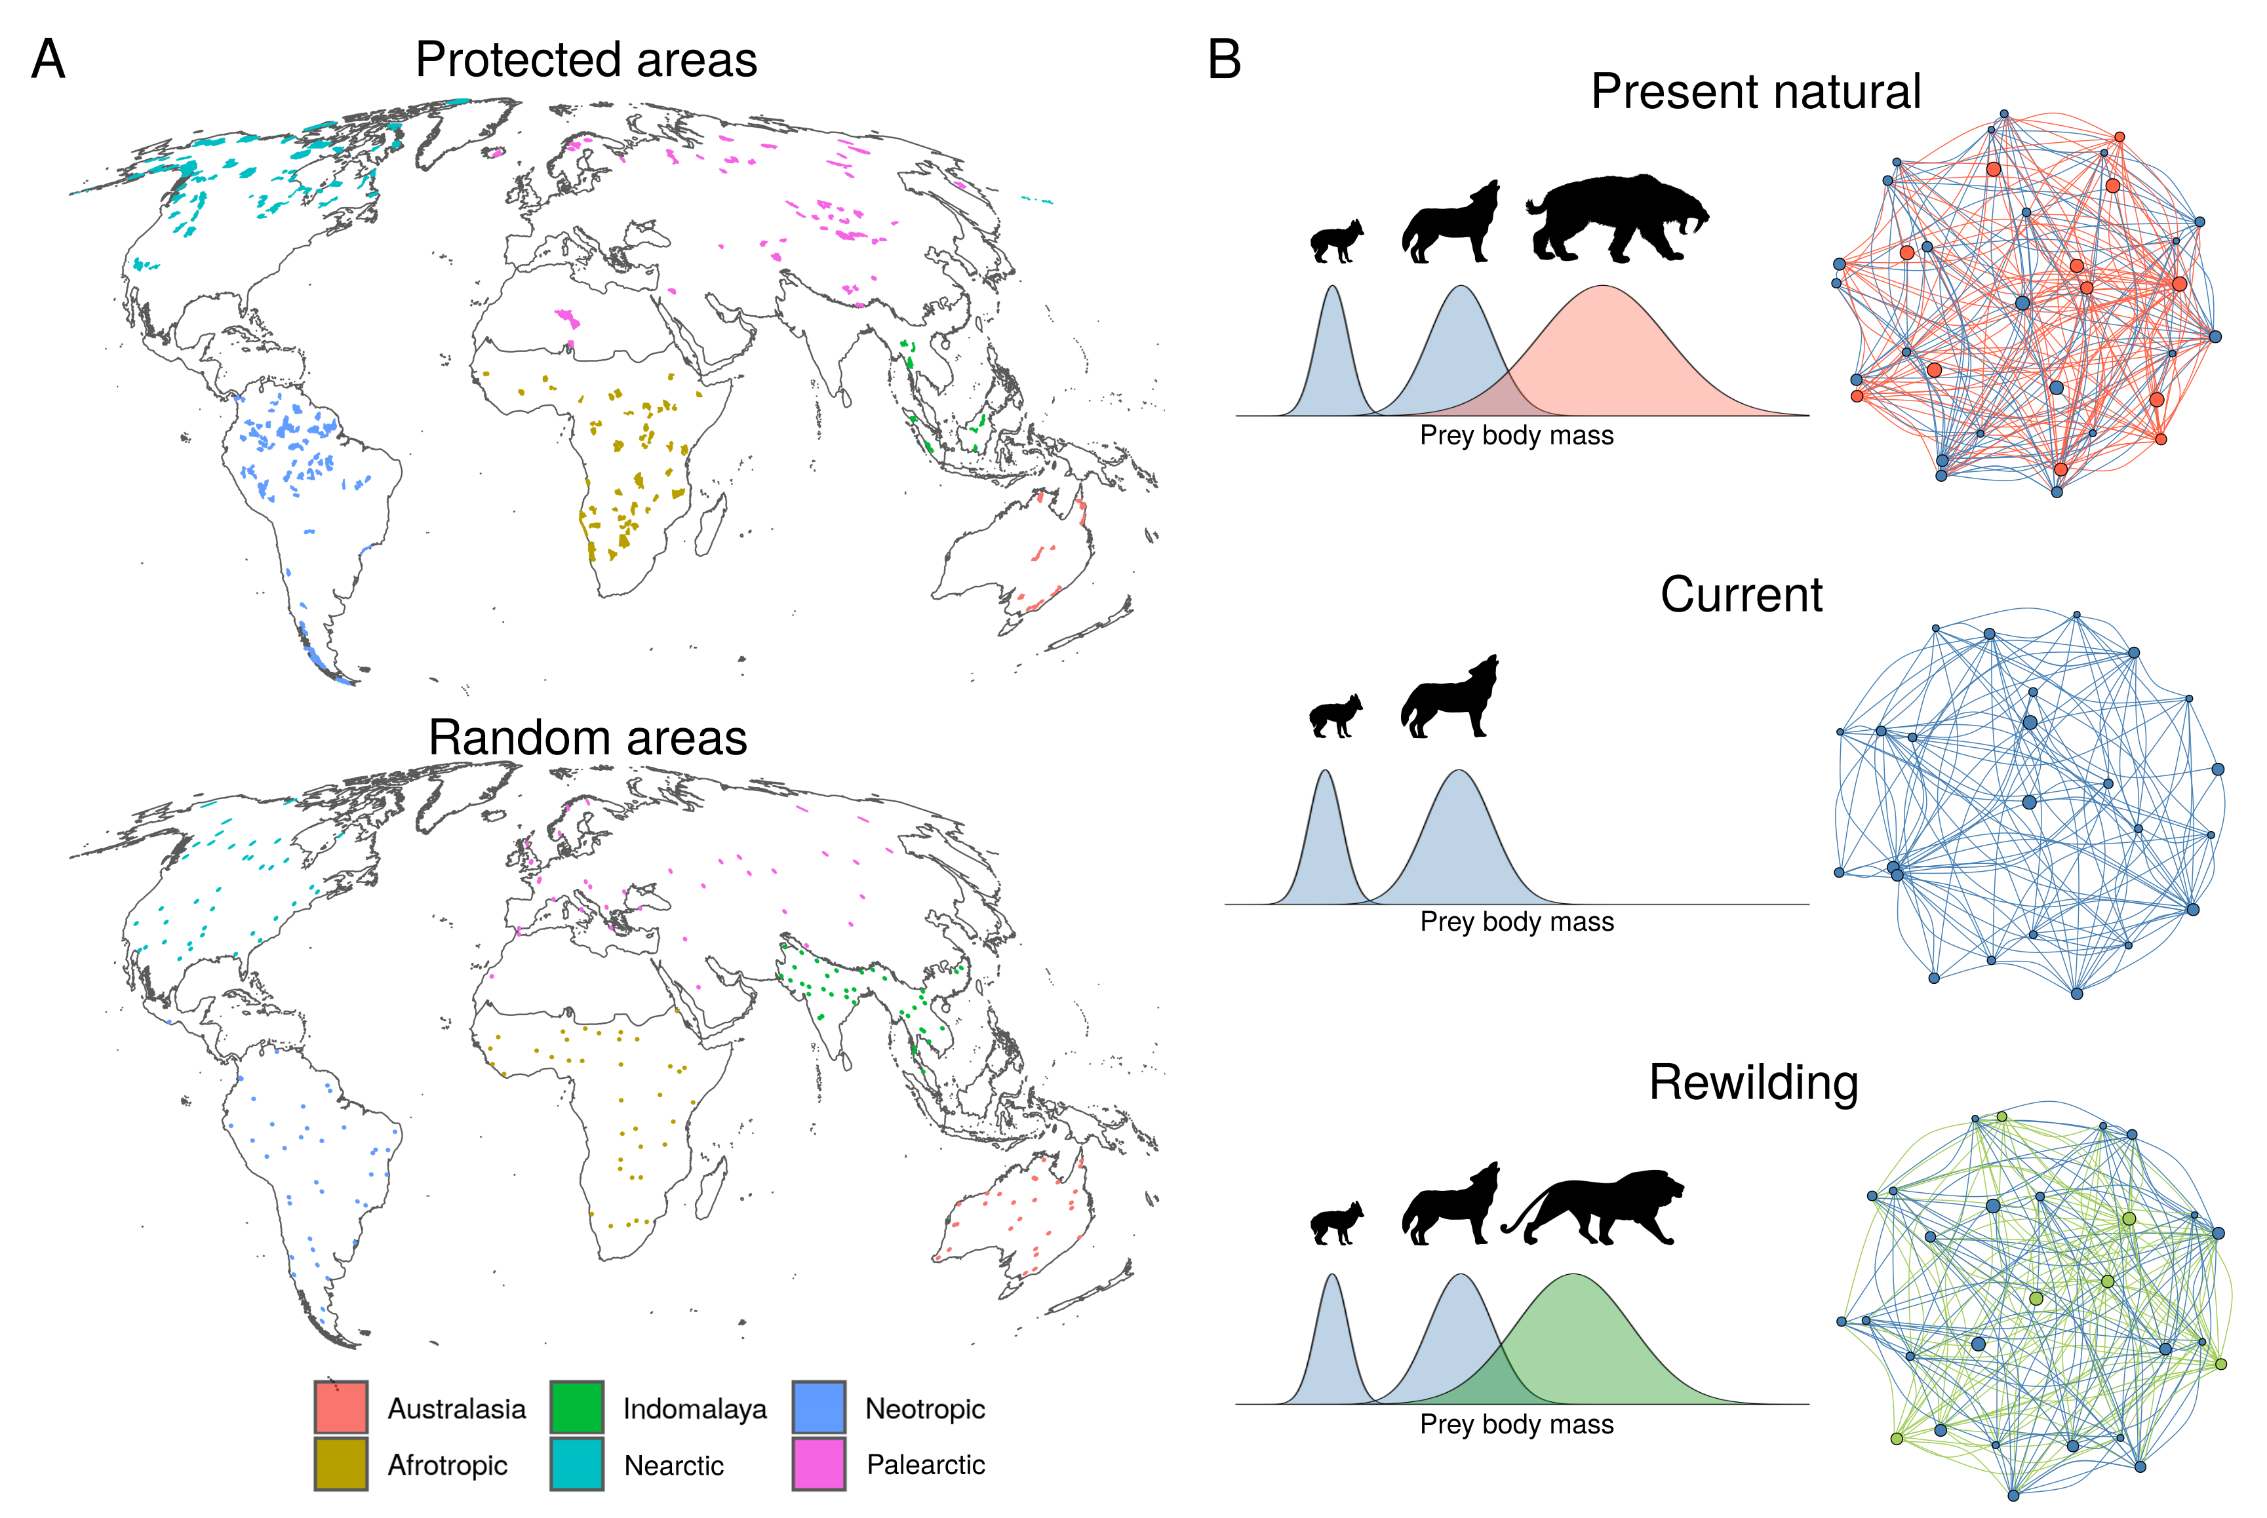

Fig. 1. Conceptual representation of rewiring food webs via trophic rewilding. A) The protected areas and random areas ≥ 5,000 km2 are coloured by the six biogeographic realms considered for trophic rewilding of terrestrial mammals. We excluded Antarctica because no terrestrial mammals live there and Oceania because no terrestrial protected areas larger than ≥ 5,000 km2 are found there. B) Network representation of food webs assessed using reconstructions of species assemblages and interactions under three modelling scenarios: present natural (communities in the absence of human), current (present day communities), rewilding (communities given reintroduction of living mammals and introduction of funcitonal analogues for extant mammals). Species are shown as circles and predator-prey interactions as lines. Red color show the species and interaction that are lost in current conditions. Green color show the species reintroduced or replaced by functional analogues and the interactions rewired. Blue color show species and interactions common to all scenarios.

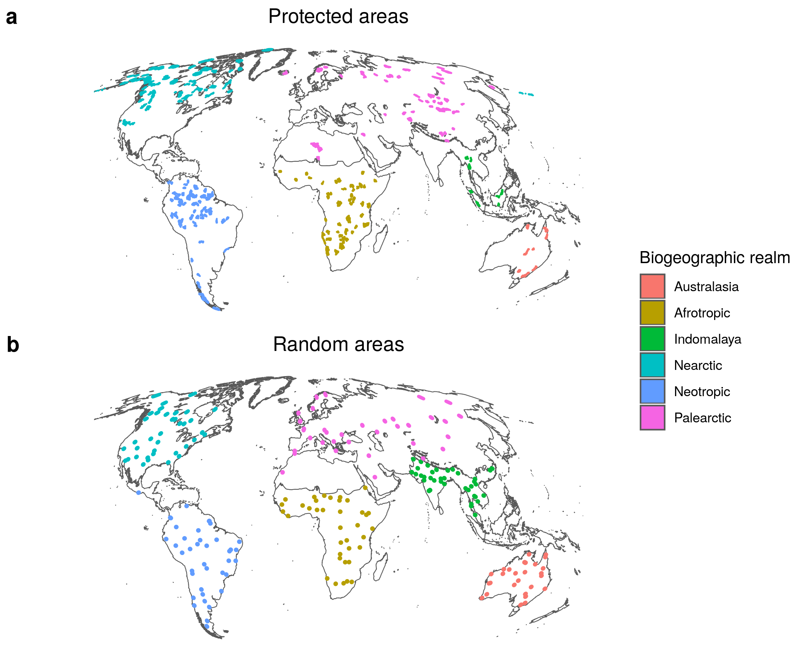Fig. 1: Map of large protected and random areas ≥ 5,000 km2 for trophic rewilding in each Biogeographic realm (colours). **a**, Protected areas with strict IUCN management categories I–II. We excluded Antarctica because no terrestrial mammals live there and Oceania because no terrestrial protected areas larger than ≥ 5,000 km2 are found there. **b**, Areas ≃ 5,026 km2 generated at random for each Biogeographic realm, used to assess if trophic rewilding was affected by geographic biases of the protected areas. Random areas are displayed larger than their real extent for easier visualization.

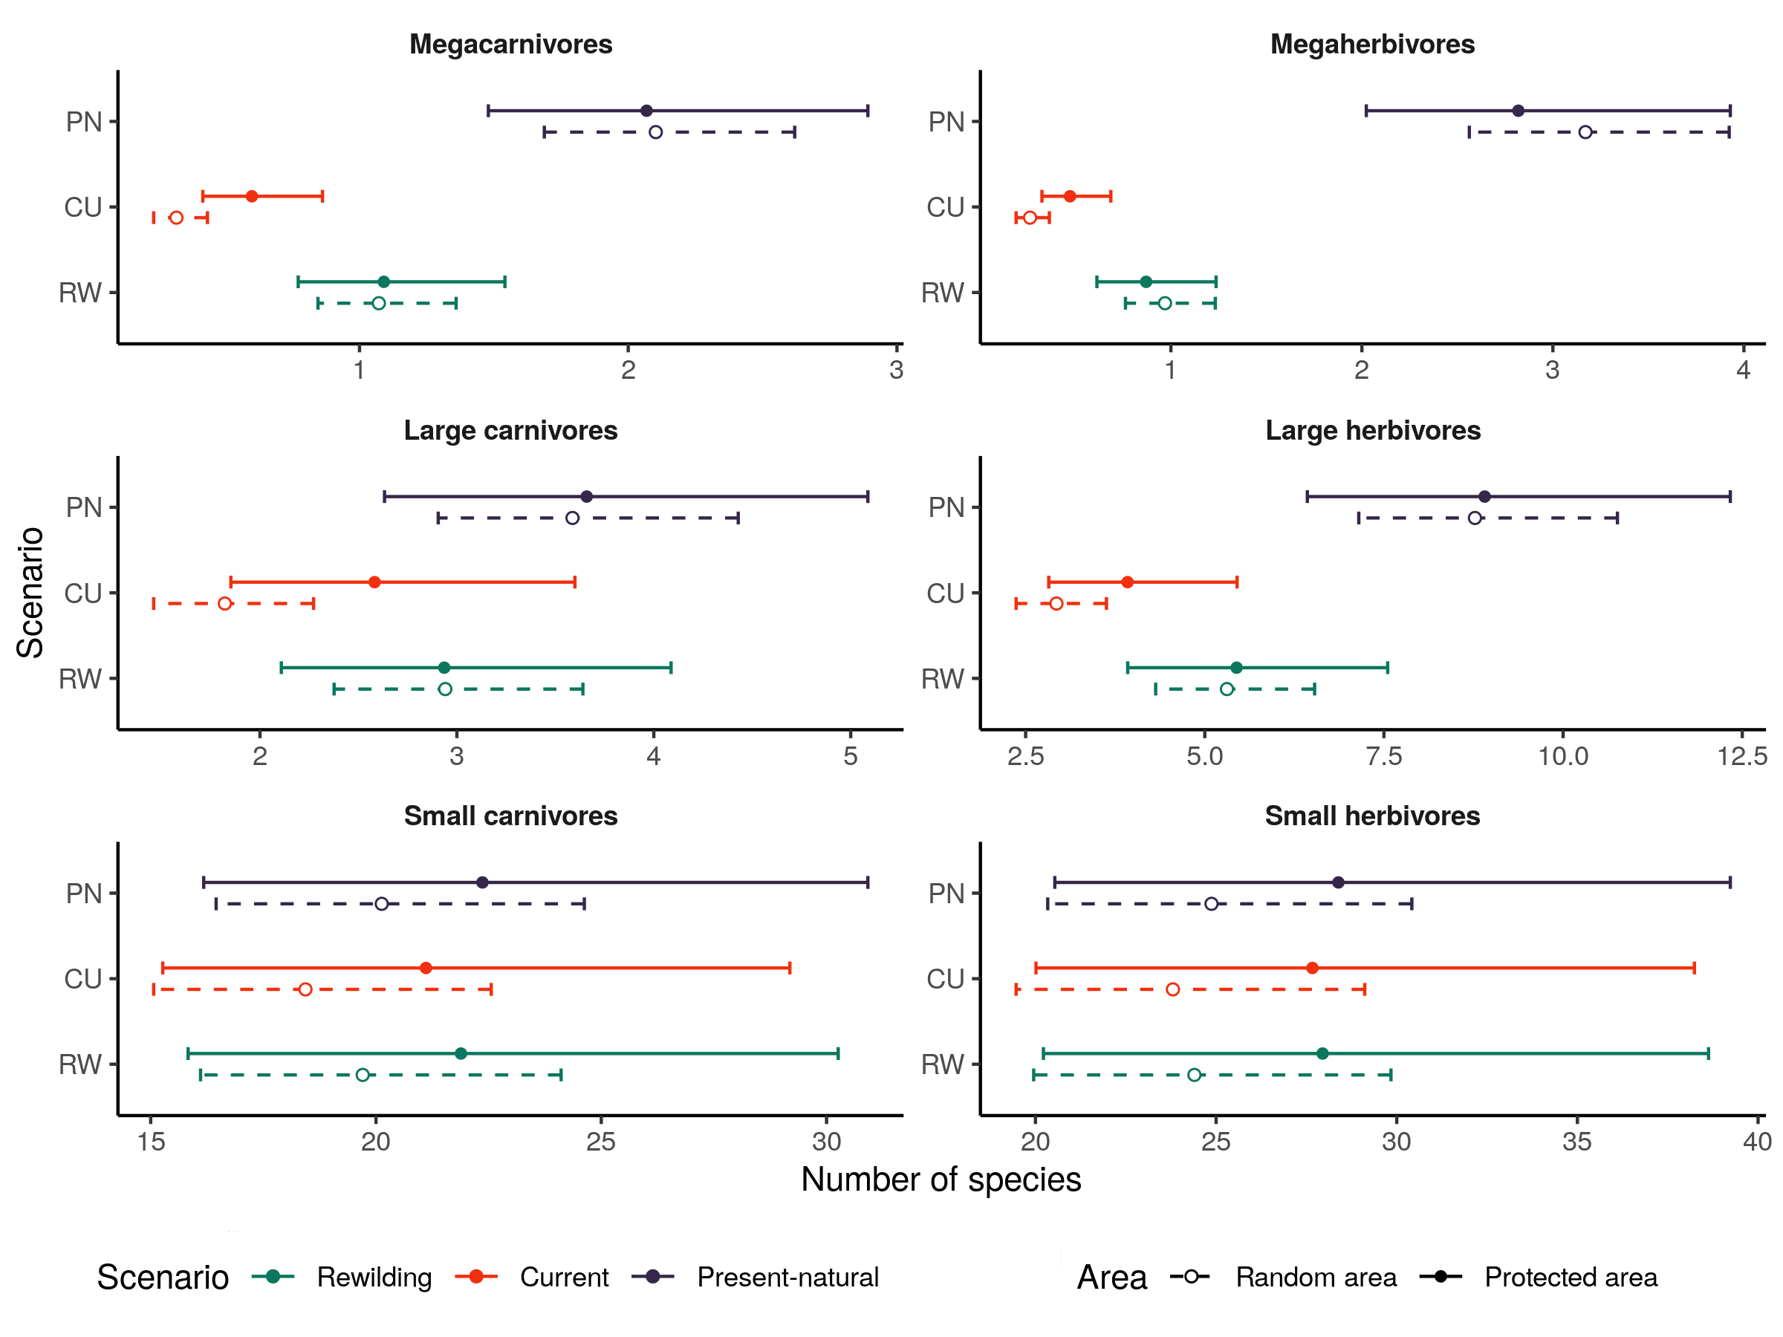

Figure 2: Model estimates of the number of species per trophic level from generalised linear mixed models (GLMMs) for three scenarios: PN, present-natural (blue); CU, current (red); and RW, rewilding (green). Circles show the estimated means from the GLMMs and lines the 95% confidence intervals for protected areas (closed circle and solid lines) and for random areas (open circle and dashed lines). The GLMMs accounted for variation across biogeographic realms and food webs**.** Trophic levels were defined following of Malhi et al. (2016) as: megacarnivores (≥ 100 kg), large carnivores (21.5–99 kg), small carnivores (< 21.5 kg), megaherbivores (≥ 1,000 kg), large herbivores (45–999 kg), and small herbivores (< 45 kg).

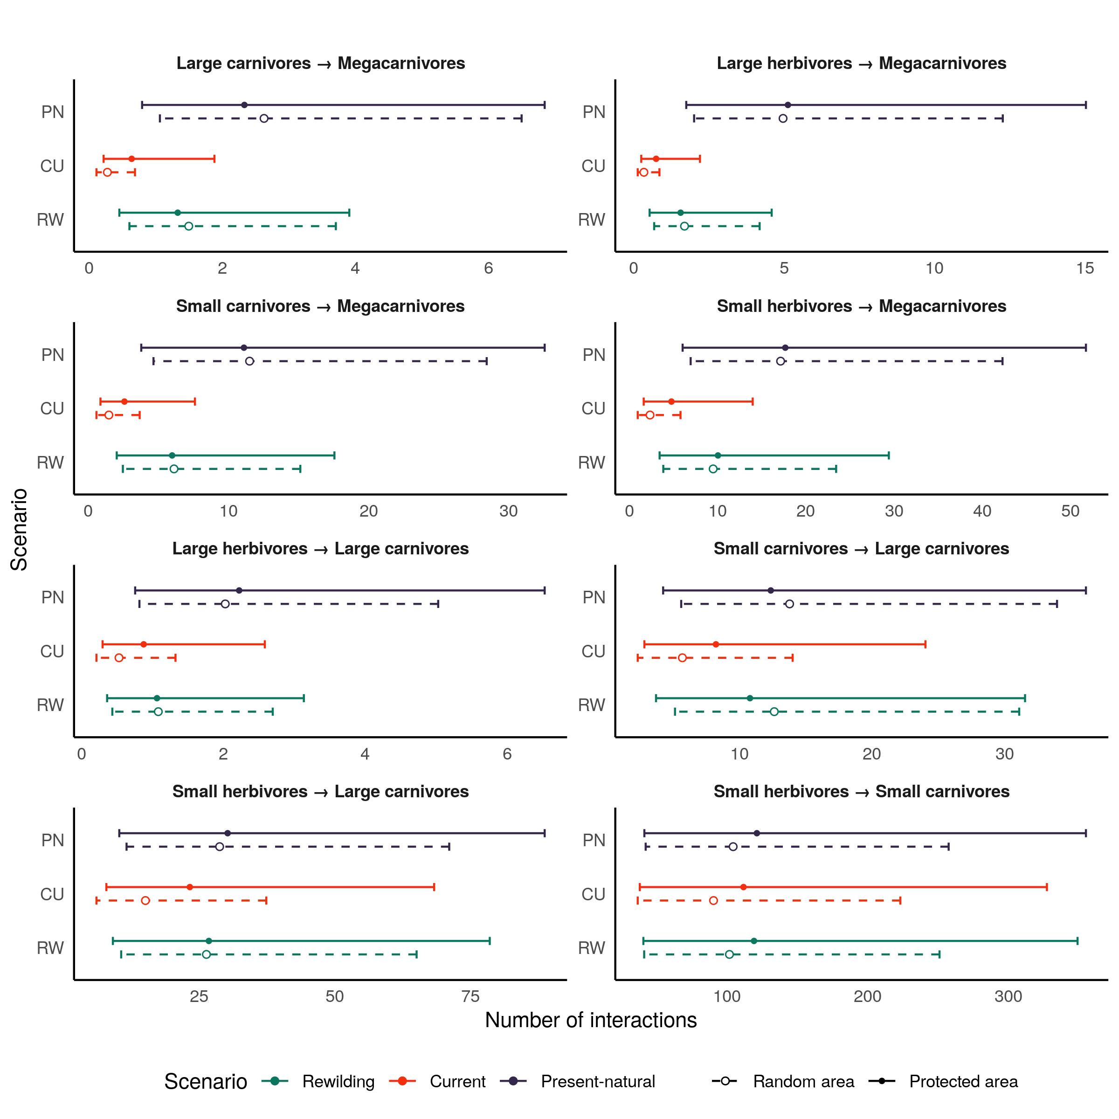Figure 3. Model estimates of the number of predator-prey interactions between each trophic level from generalised linear mixed models (GLMMs) for three scenarios: PN, present-natural (blue); CU, current (red); RW, rewilding (green). Circles show the estimated means and lines the 95% confidence intervals for protected areas (closed circle and solid lines) and for random areas (open circle and dashed lines).The GLMMs accounted for variation across biogeographic realms and food webs. For the definitions of trophic levels see the caption of Fig. 1. Megaherbivores were free from predation in all food webs.

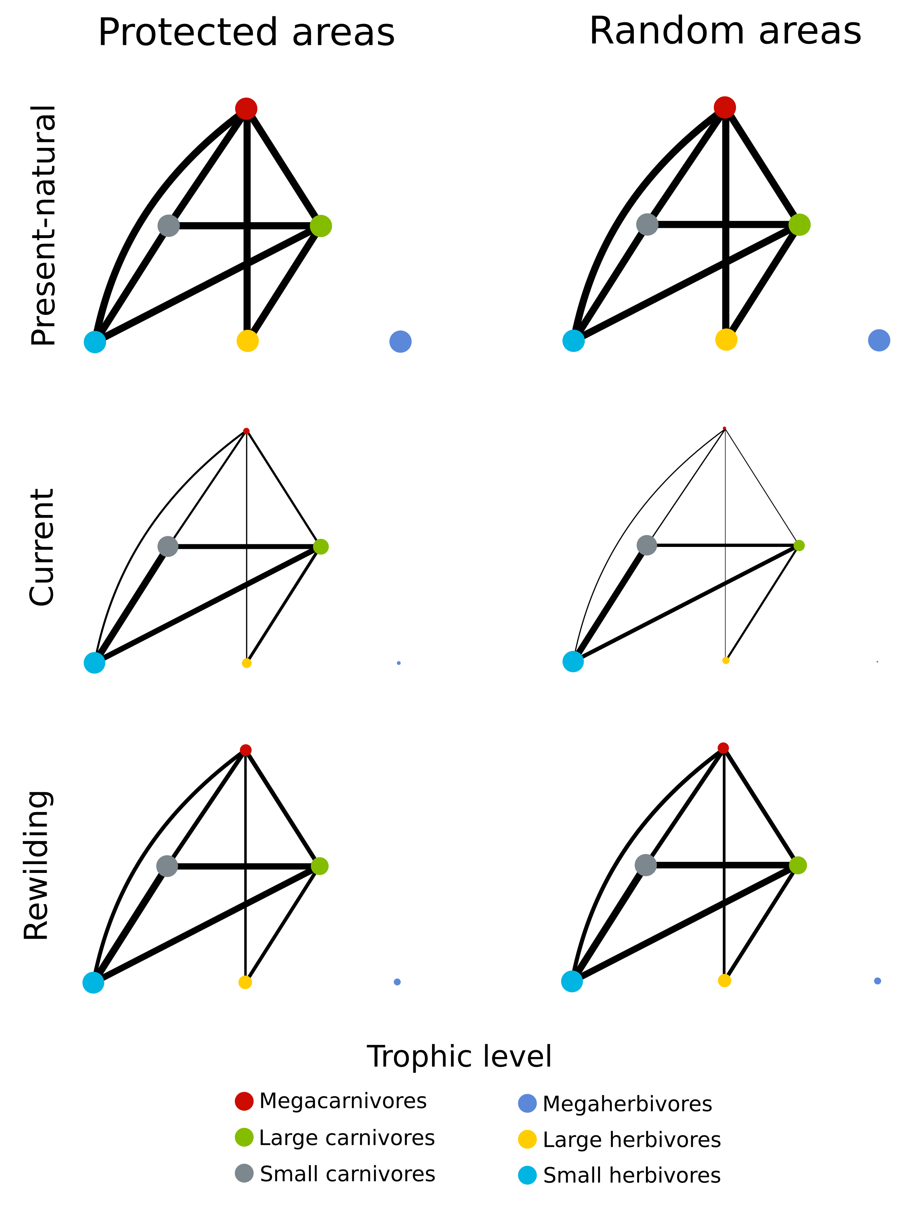Figure 4: Network representation of the mean estimates from GLMMs for the food webs in the three scenarios. Circles are trophic levels and lines the predator-prey interactions. Circles and lines are normalised for the present-natural values, our reference baseline. Circle colours show the trophic levels.

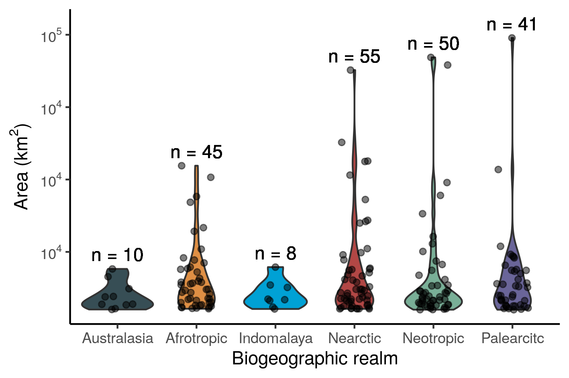

Figure 5: Area size of the protected areas studied for the six biogeographic realm. The violin plots show the distribution of area size per realm and the points the individual protected areas, with the number (n) of area per realm displayed.